Assignment
Spring 2026 2nd Semester
Topic(s): Lab 2 Measurements of Waveforms and Fundamental Quantities, Basic resistive circuits.
SUBMITTED TO:
Mr. Mehmood-ul-Haq
SUBMITTED BY:
Ayesha Naseem (2025-CE-19)
Submission Date: 17 Mar, 2026
Department of Computer Engineering
University of Engineering and Technology Lahore
Main Campus
Course Title: Circuit Analysis Lab
Course Code: CMPE-121L

Full Calculations for Experiment 1
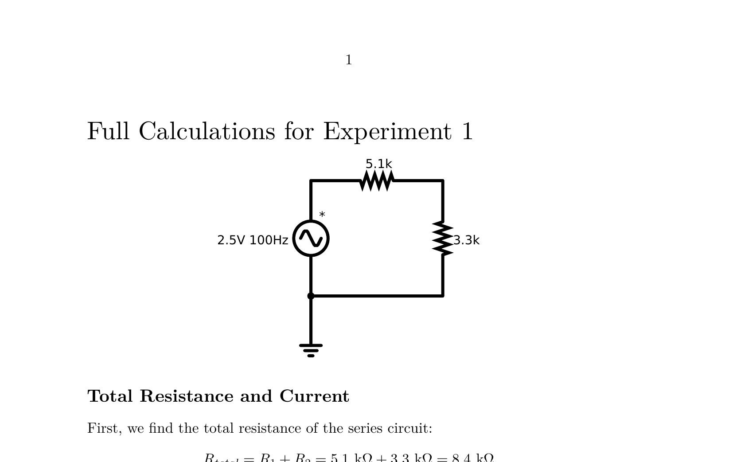
Circuit: 5.1kΩ and 3.3kΩ series resistors with 2.5V 100Hz source

Total Resistance and Current
First, we find the total resistance of the series circuit:
Rtotal = R1 + R2 = 5.1 kΩ + 3.3 kΩ = 8.4 kΩ

Calculations for Resistor R1 (5.1 kΩ)
Using the Voltage Divider Rule to find the peak-to-peak voltage (Vp−p):
Vp−p(R1) = Vin × (R1 / Rtotal) = 5 V × (5.1 kΩ / 8.4 kΩ) ≈ 3.036 V
Converting the peak-to-peak value to RMS voltage (Vrms):
Vrms(R1) = Vp−p(R1) / (2√2) = 3.036 V / 2.8284 ≈ 1.073 V

Calculations for Resistor R2 (3.3 kΩ)
Using the Voltage Divider Rule for Vp−p:
Vp−p(R2) = Vin × (R2 / Rtotal) = 5 V × (3.3 kΩ / 8.4 kΩ) ≈ 1.964 V
Converting the peak-to-peak value to RMS voltage (Vrms):
Vrms(R2) = Vp−p(R2) / (2√2) = 1.964 V / 2.8284 ≈ 0.694 V

Verification (KVL)
The sum of the individual peak-to-peak voltages should equal the source voltage:
ΣV = Vp−p(R1) + Vp−p(R2) = 3.036 V + 1.964 V = 5.000 V
Since 5.000 V = Vin, Kirchhoff’s Voltage Law is satisfied.

Calculated Data and Results
Resistor | Input Voltage, Vin | RMS Voltage, Vrms | P-P Voltage, Vp-p
R1 (5.1kΩ) | 5.00 V | 1.07 V | 3.04 V
R2 (3.3kΩ) | 5.00 V | 0.69 V | 1.96 V
Oscilloscope Waveform Measurements
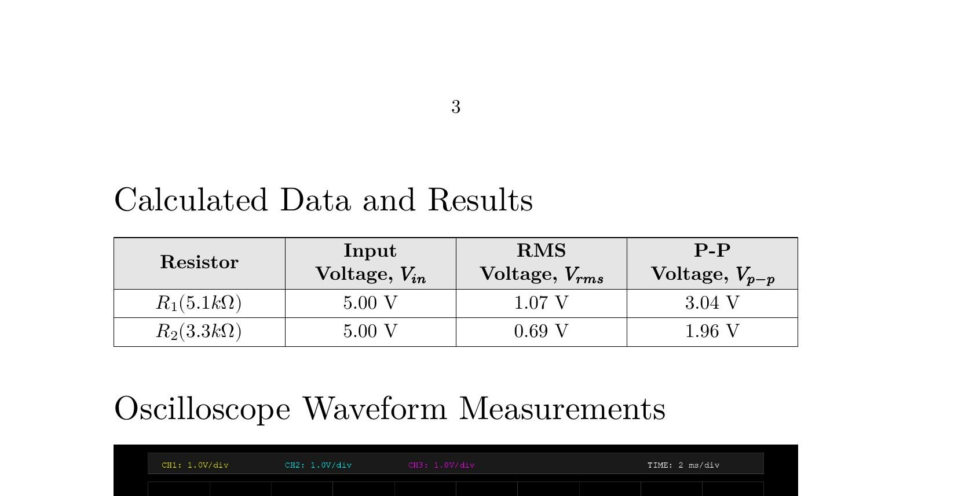
Figure 1 Simulated oscilloscope drawn using gnuplot, with 3 channels ON and probed at unique points in circuit
(a) Input voltage signal
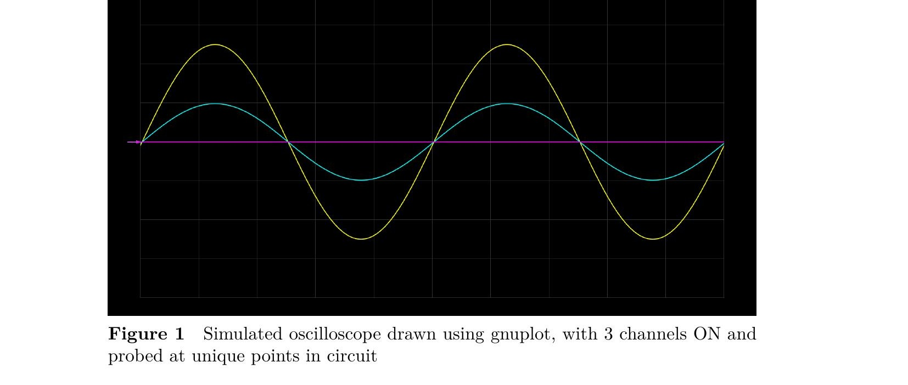
(b) Voltage signal across R1

(c) Voltage signal across R2
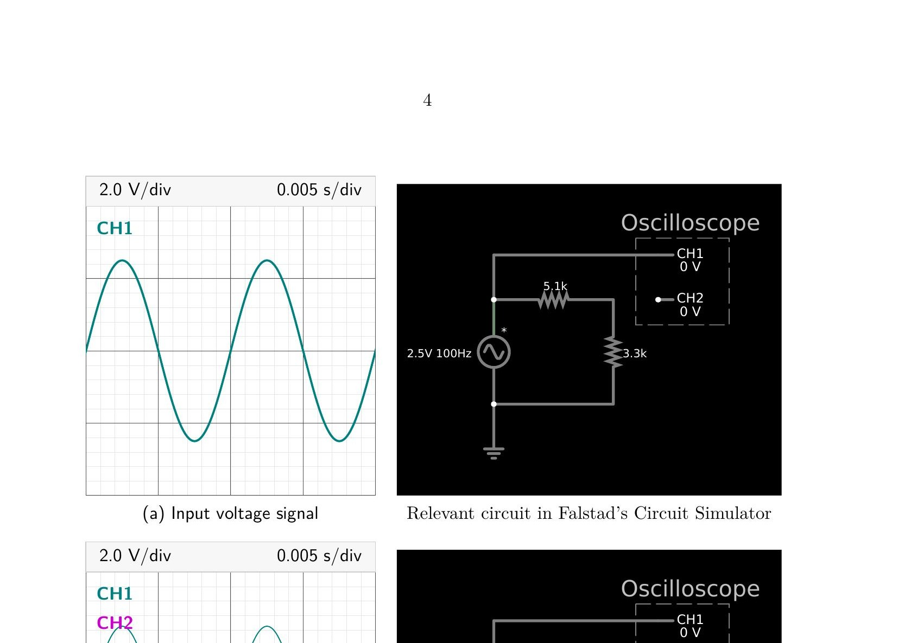
(d) 7V Sinusoidal
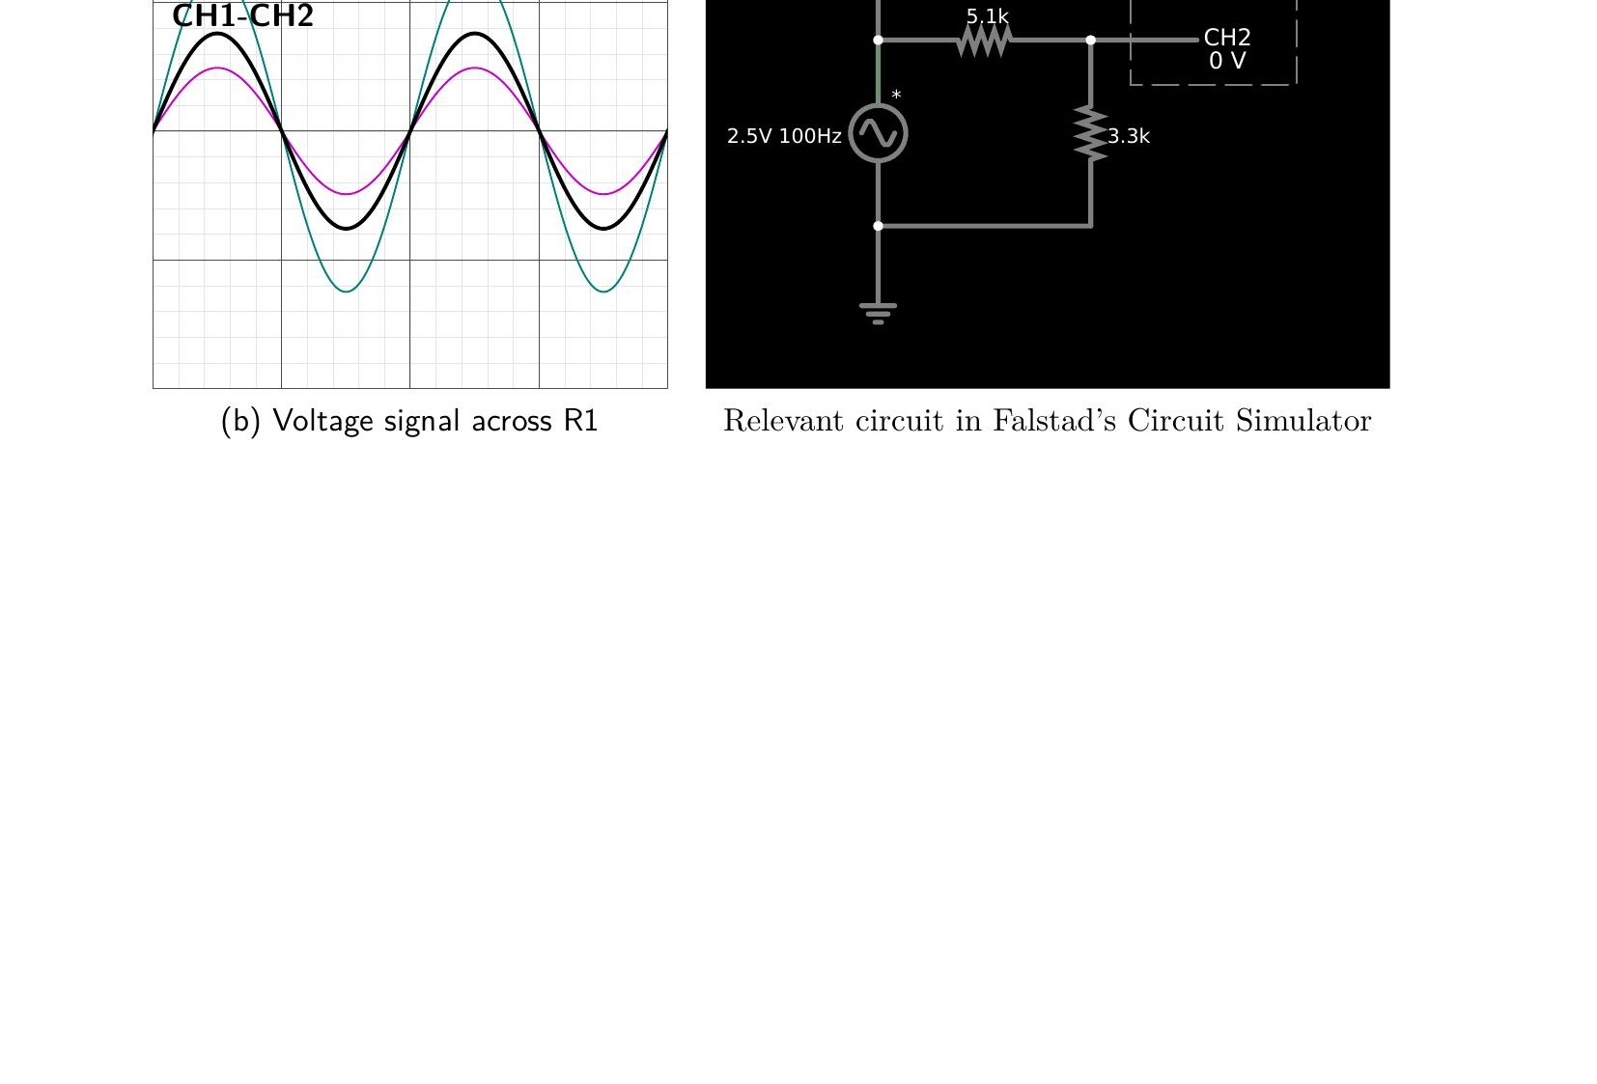

Full Calculations for Experiment 2
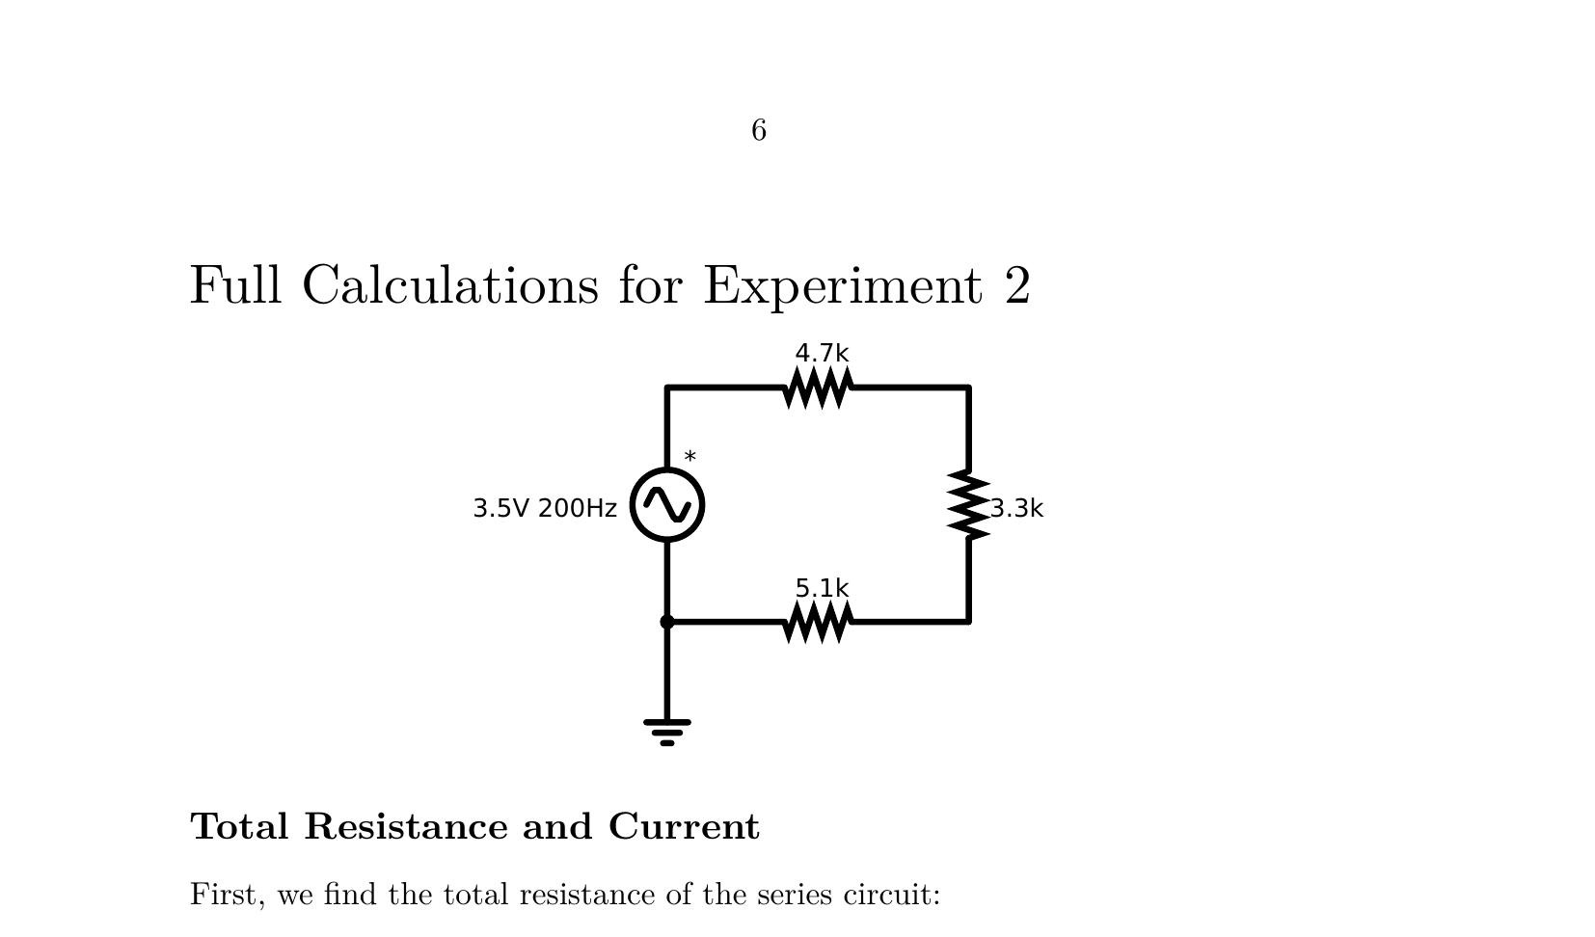
Circuit: 4.7kΩ, 3.3kΩ, 5.1kΩ series resistors with 3.5V 200Hz source

Total Resistance and Current
First, we find the total resistance of the series circuit:
Rtotal = R1 + R2 + R3 = 4.7 kΩ + 3.3 kΩ + 5.1 kΩ = 13.1 kΩ

Calculations for Resistor R1 (4.7 kΩ)
Using the Voltage Divider Rule to find the peak-to-peak voltage (Vp−p):
Vp−p(R1) = Vin × (R1 / Rtotal) = 7 V × (4.7 kΩ / 13.1 kΩ) ≈ 2.511 V
Converting the peak-to-peak value to RMS voltage (Vrms):
Vrms(R1) = Vp−p(R1) / (2√2) = 2.511 V / 2.8284 ≈ 0.888 V

Calculations for Resistor R2 (3.3 kΩ)
Using the Voltage Divider Rule for Vp−p:
Vp−p(R2) = Vin × (R2 / Rtotal) = 7 V × (3.3 kΩ / 13.1 kΩ) ≈ 1.763 V
Converting the peak-to-peak value to RMS voltage (Vrms):
Vrms(R2) = Vp−p(R2) / (2√2) = 1.763 V / 2.8284 ≈ 0.623 V

Calculations for Resistor R3 (5.1 kΩ)
Using the Voltage Divider Rule for Vp−p:
Vp−p(R3) = Vin × (R3 / Rtotal) = 7 V × (5.1 kΩ / 13.1 kΩ) ≈ 2.725 V
Converting the peak-to-peak value to RMS voltage (Vrms):
Vrms(R3) = Vp−p(R3) / (2√2) = 2.725 V / 2.8284 ≈ 0.963 V

Voltage across R1+R2
Using the Voltage Divider Rule to find the peak-to-peak voltage (Vp−p):
Vp−p(R1+R2) = Vin × ((R1+R2) / Rtotal) = 7 V × (8.0 kΩ / 13.1 kΩ) ≈ 4.275 V
Converting the peak-to-peak value to RMS voltage (Vrms):
Vrms(R1+R2) = 4.275 V / 2.8284 ≈ 1.511 V

Voltage across R2+R3
Using the Voltage Divider Rule to find the peak-to-peak voltage (Vp−p):
Vp−p(R2+R3) = Vin × ((R2+R3) / Rtotal) = 7 V × (8.4 kΩ / 13.1 kΩ) ≈ 4.489 V
Converting the peak-to-peak value to RMS voltage (Vrms):
Vrms(R2+R3) = 4.489 V / 2.8284 ≈ 1.587 V

Verification (KVL)
The sum of the individual peak-to-peak voltages should equal the source voltage:
ΣV = Vp−p(R1) + Vp−p(R2) + Vp−p(R3) = 2.511 V + 1.763 V + 2.725 V ≈ 6.999 V
Since 6.999 V ≈ 7 V = Vin, Kirchhoff’s Voltage Law is satisfied (within rounding limits).

Calculated Data and Results
Resistor | Input Voltage, Vin | RMS Voltage, Vrms | P-P Voltage, Vp-p
R1 (4.7kΩ) | 7.00 V | 0.89 V | 2.51 V
R2 (3.3kΩ) | 7.00 V | 0.62 V | 1.76 V
R3 (5.1kΩ) | 7.00 V | 0.96 V | 2.73 V
R1+R2 | 7.00 V | 1.51 V | 4.28 V
R2+R3 | 7.00 V | 1.59 V | 4.49 V
Oscilloscope Waveform Measurements
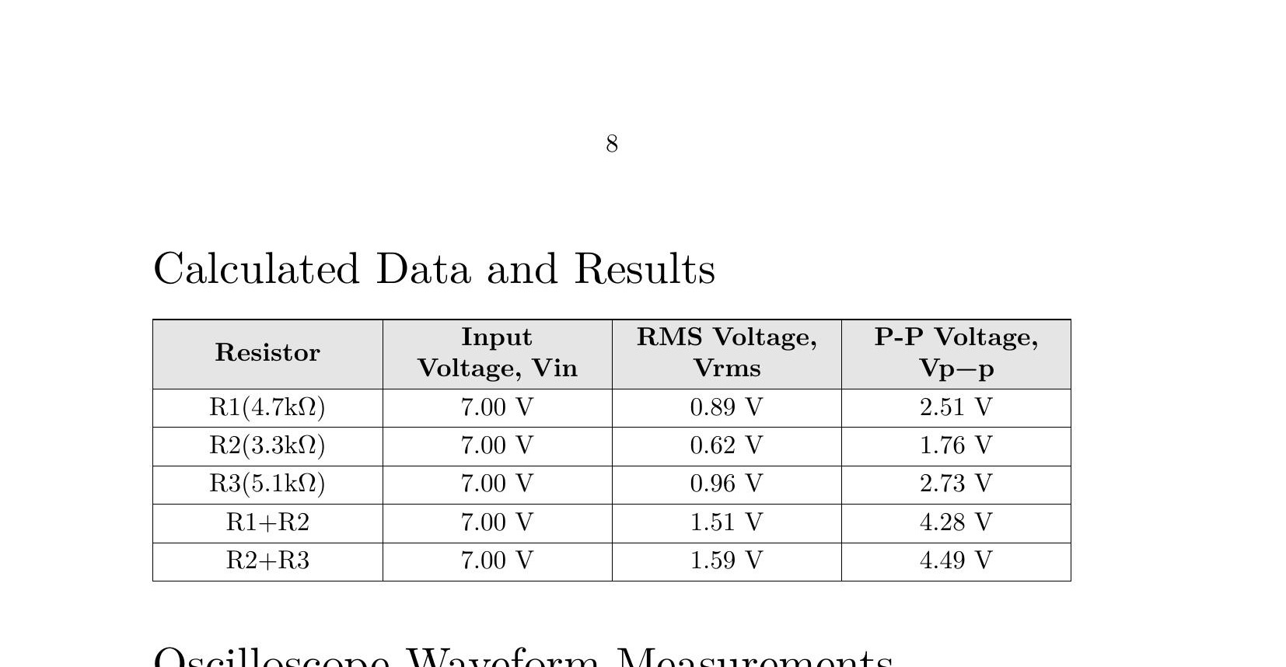
Figure 2 Simulated oscilloscope drawn using gnuplot, with 4 channels ON and probed at unique points in circuit
(a) Input voltage signal
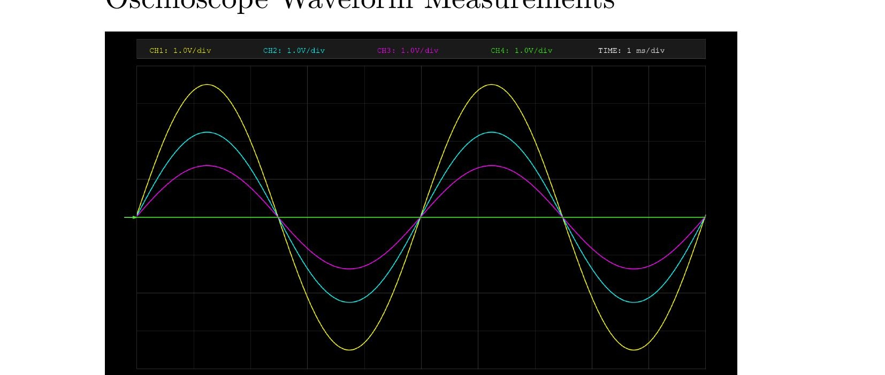
(b) Voltage signal across R1
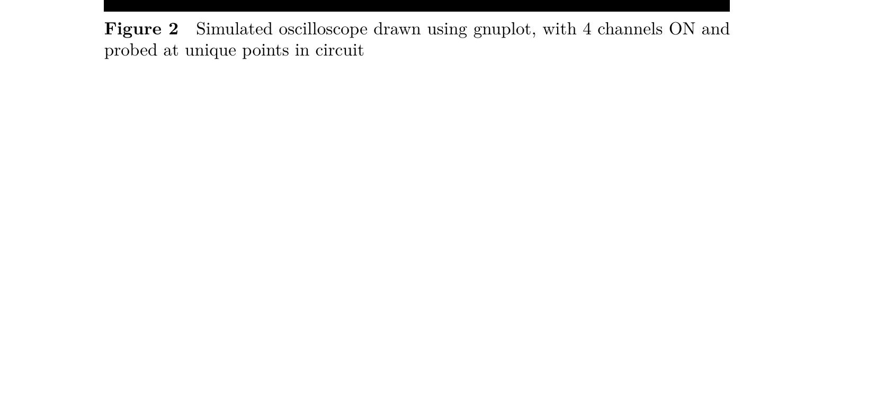
(c) Voltage signal across R2
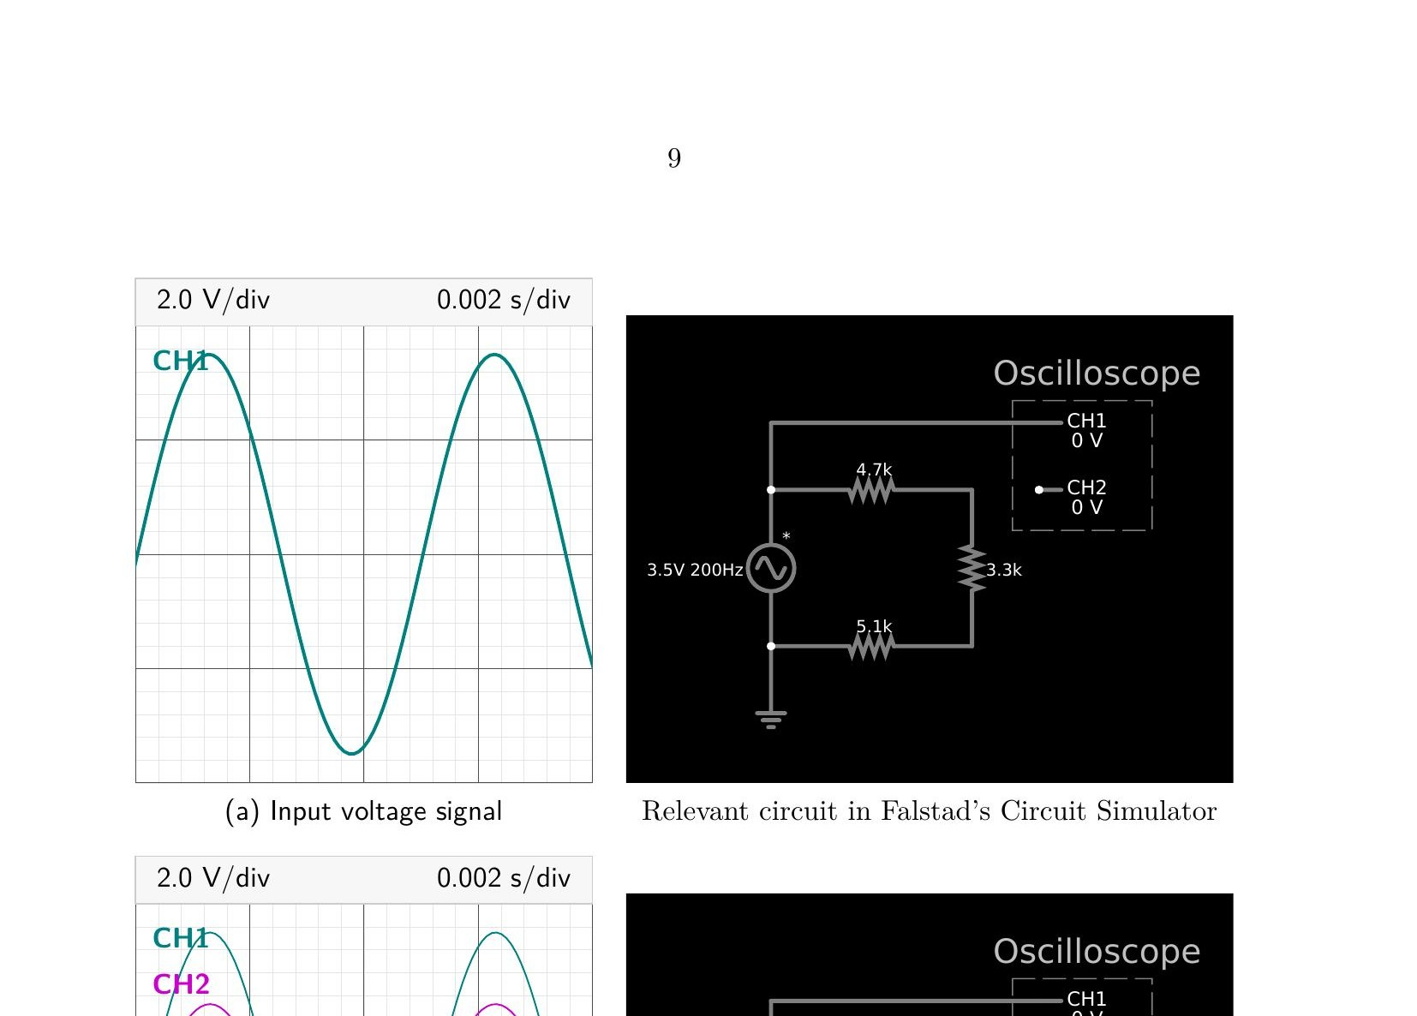
(d) Voltage signal across R3
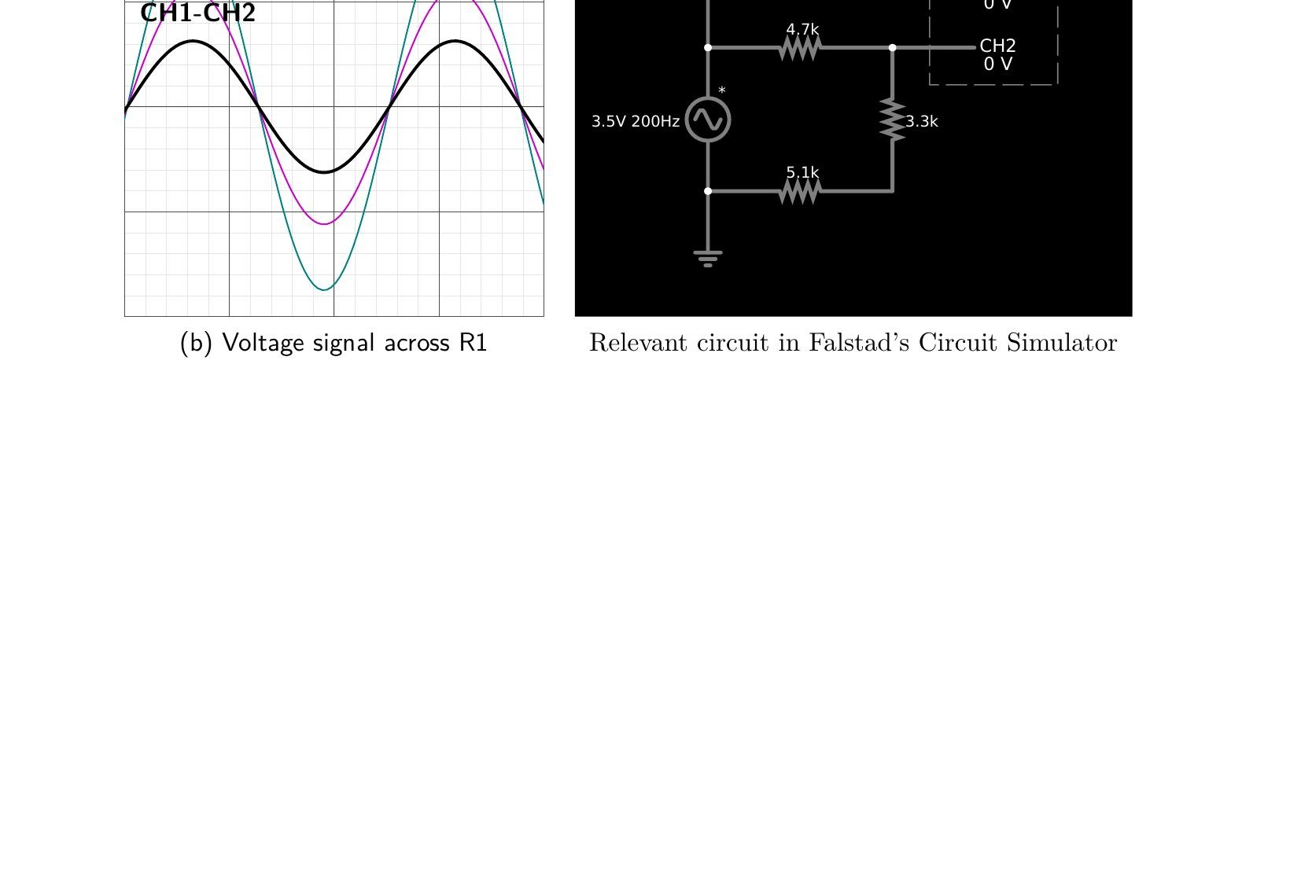
(e) Voltage signal across R1 and R2
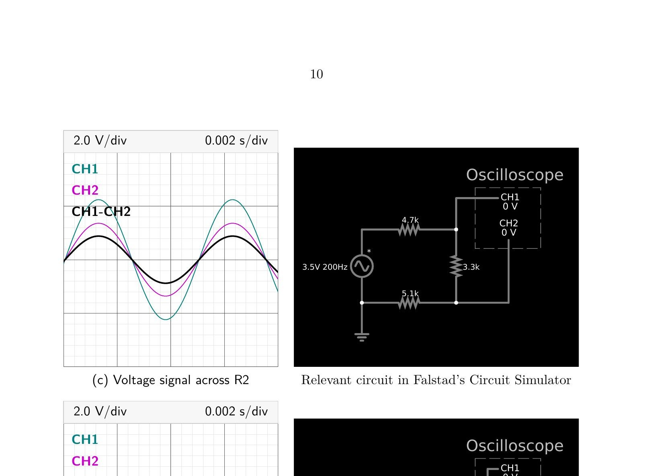
(f) Voltage signal across R2 and R3
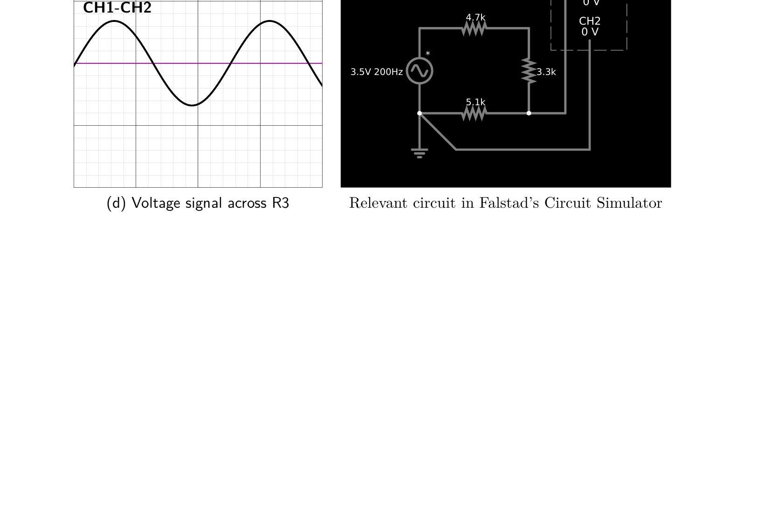

Post-Lab Questions

1. Define Ohm’s Law.
Ohm’s Law states that the current flowing through a conductor is directly proportional to the voltage applied across it, provided that temperature and other physical conditions remain constant.
Mathematically, it is expressed as V = IR, where V is the voltage across the resistor, I is the current flowing through it, and R is the resistance. This law is fundamental for analyzing and designing electrical circuits.

2. What is resistor?
A resistor is a passive electronic component that opposes the flow of electric current in a circuit. Its main function is to limit or control the current and to divide voltages within electronic circuits.
Resistors are commonly used for current limiting, voltage division, biasing active components, and protecting sensitive components from excessive current.

3. How resistor works?
A resistor works by providing opposition to the movement of electric charges through a conductor. When current flows through the resistor, the electrical energy is partially converted into heat due to collisions between electrons and atoms inside the resistive material.
The amount of current that flows through the resistor depends on the applied voltage and the resistance value according to Ohm’s Law.

4. What is your inference from the input and output waveforms on oscilloscope?
From the oscilloscope waveforms it can be observed that the output voltages across different resistors follow the voltage divider rule in a series circuit. The waveform shape remains sinusoidal, the same as the input signal, but the amplitude changes depending on the resistance across which the voltage is measured.
The sum of the voltages across all resistors equals the input voltage, which verifies Kirchhoff’s Voltage Law. This confirms that the circuit behavior matches the theoretical analysis.

5. Show calculations of 7V input signal from signal generator (Figure (a) in Experiment 2 readings)
For the input sinusoidal signal, we derive the values from the oscilloscope display settings:
Vertical Scale: 2.0 V/div Horizontal Scale: 0.002 s/div
Voltage Calculations from Divisions
Vp−p = 3.5 div × 2.0 V/div = 7.0 V
Vp = 7.0 V / 2 = 3.5 V
Vrms = 3.5 V / √2 = 3.5 V / 1.414 ≈ 2.475 V
Frequency Calculations from Divisions
T = 2.5 div × 0.002 s/div = 0.005 s
f = 1 / T = 1 / 0.005 s = 200 Hz
Circuit Current
Irms = Vrms / Rtotal = 2.475 V / (13.1 × 10³ Ω) ≈ 0.0001889 A = 0.189 mA

